Nama : Andri Firman Saputra  
NIM : 201011402125  
Kelas : 05TPLP016  
Tugas : Basis Data II – Pertemuan 11

Study Kasus 1

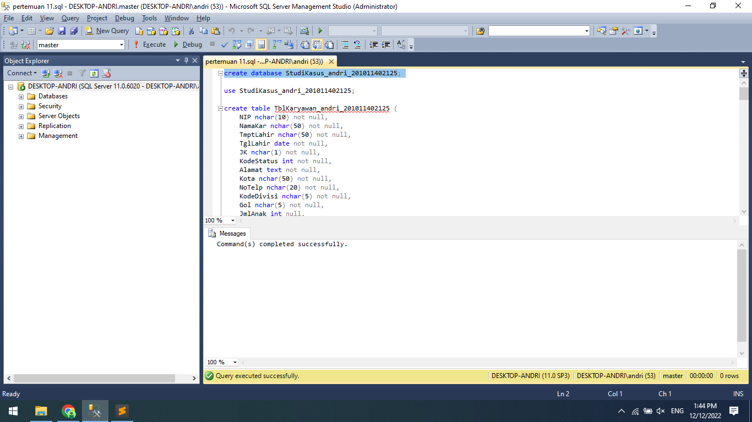

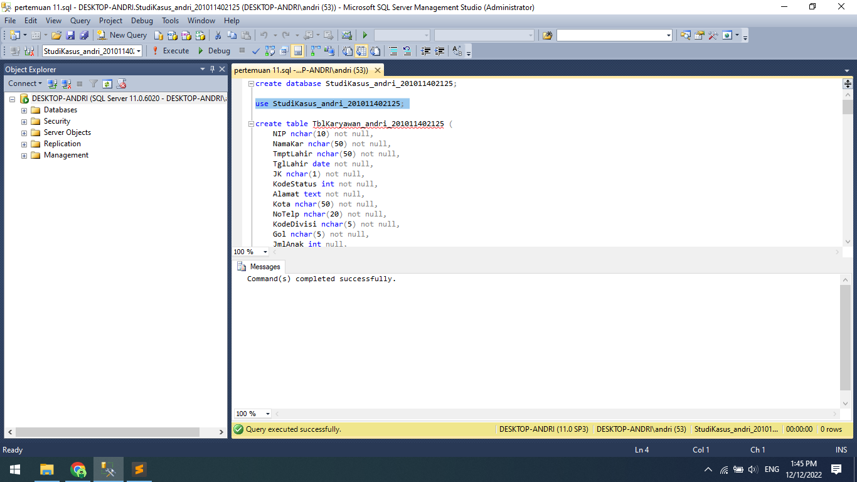

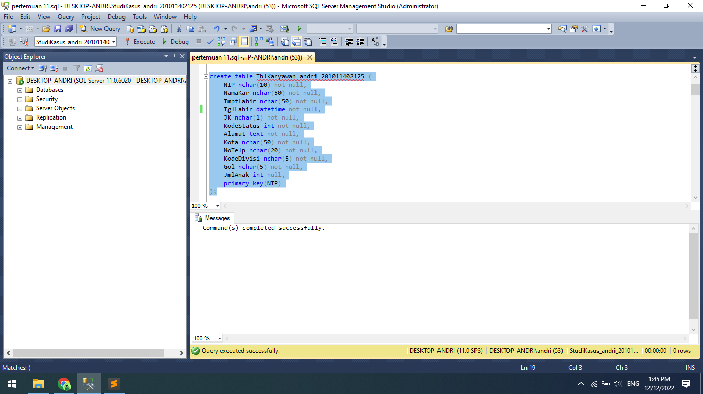

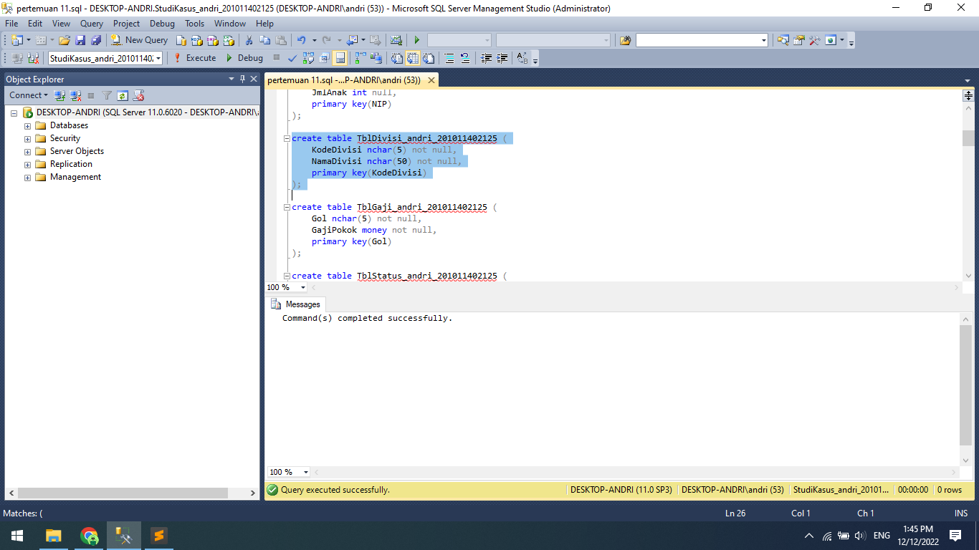

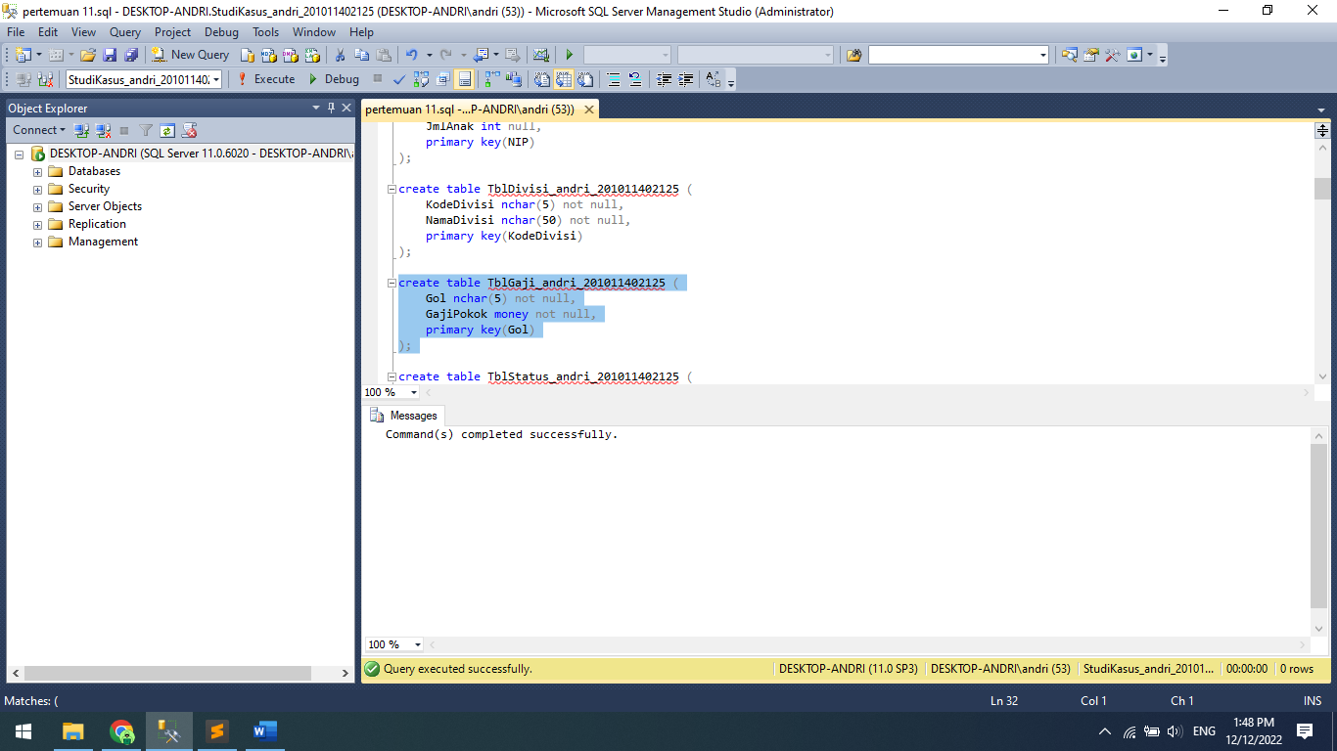

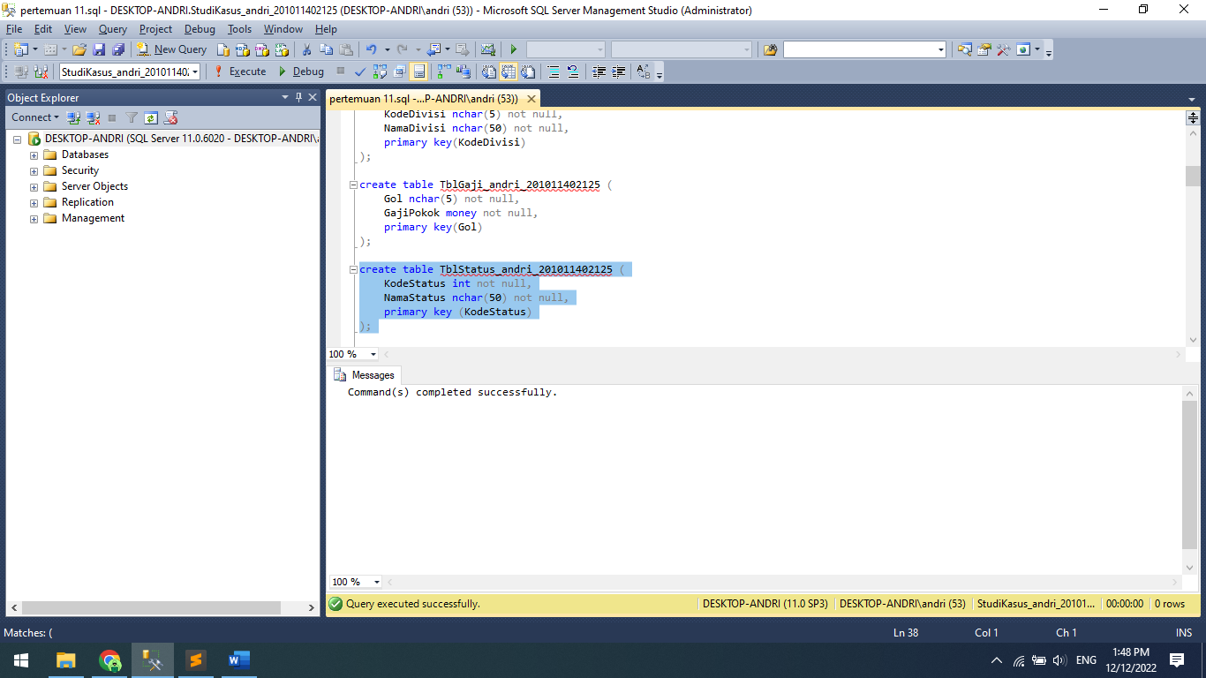

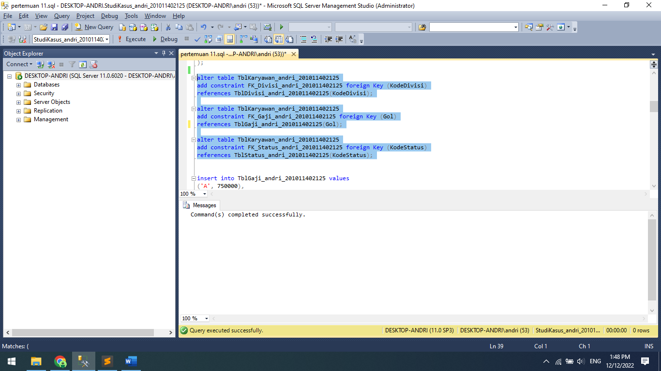

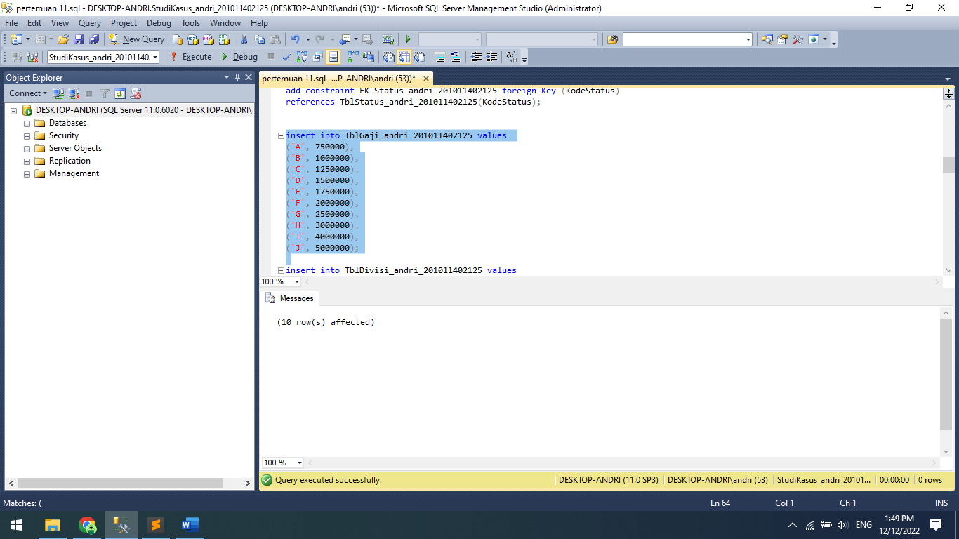

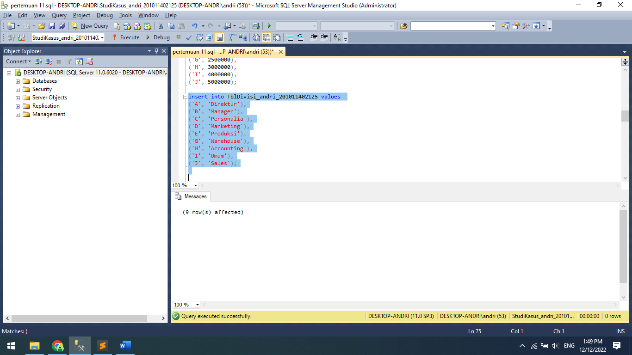

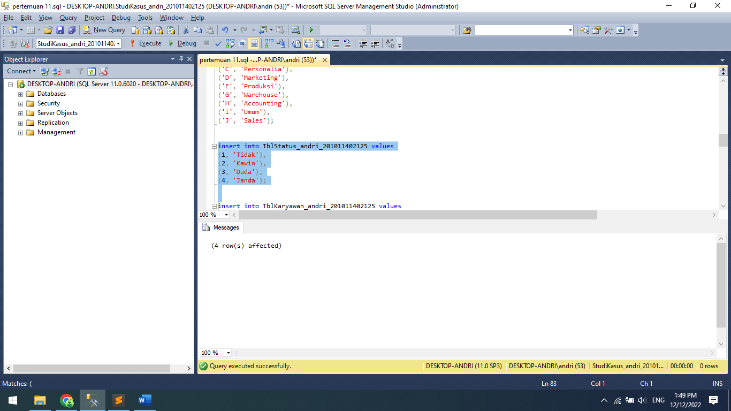

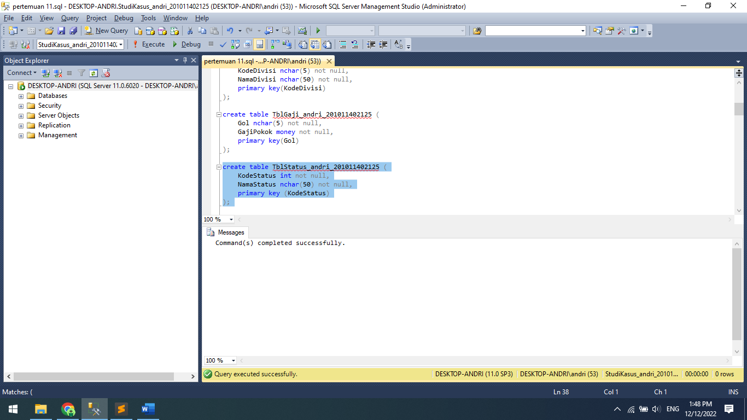

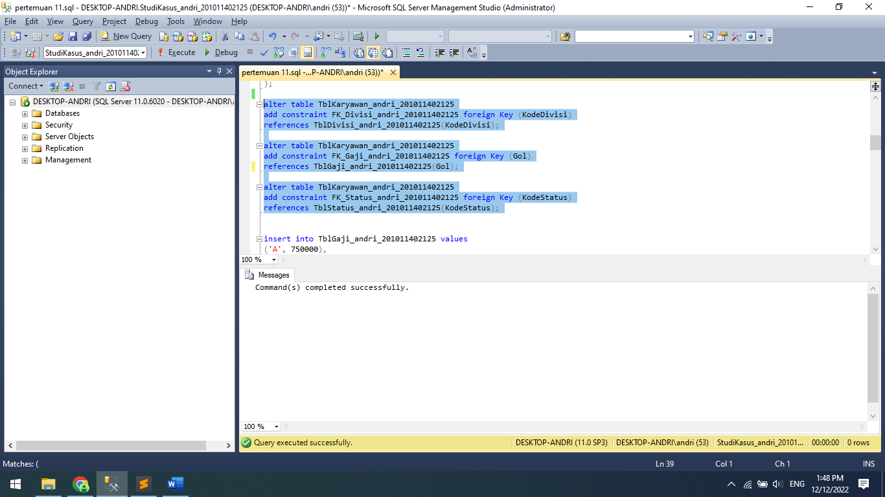

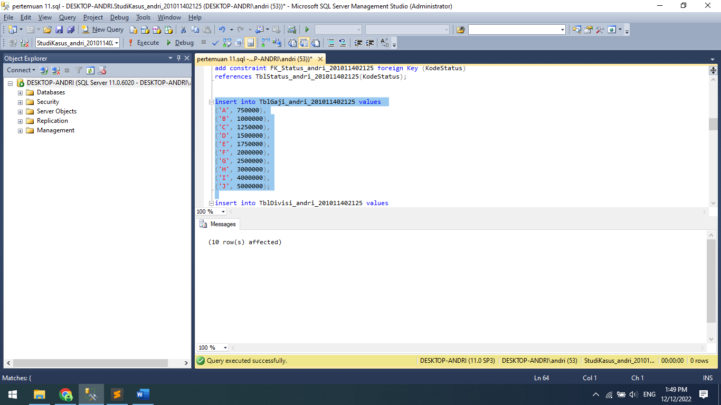

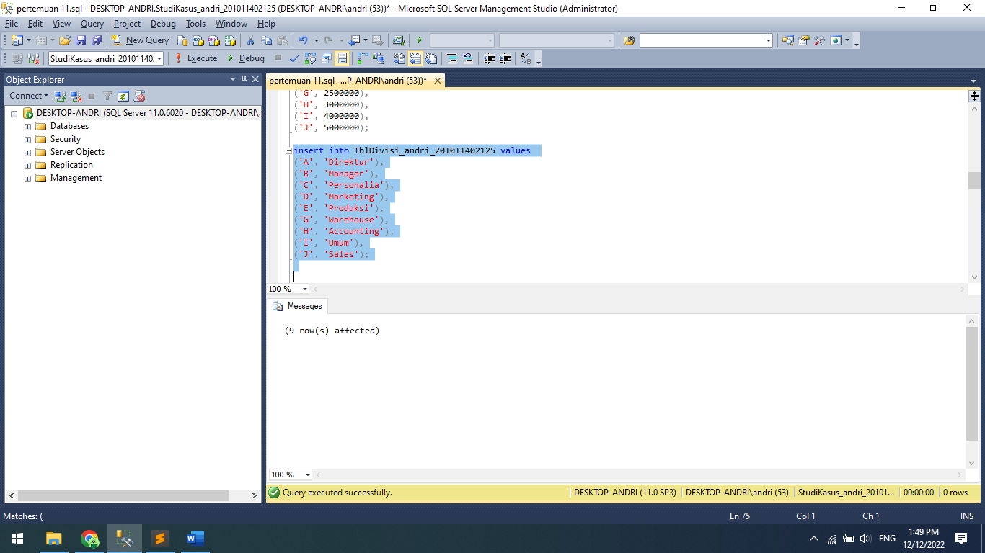

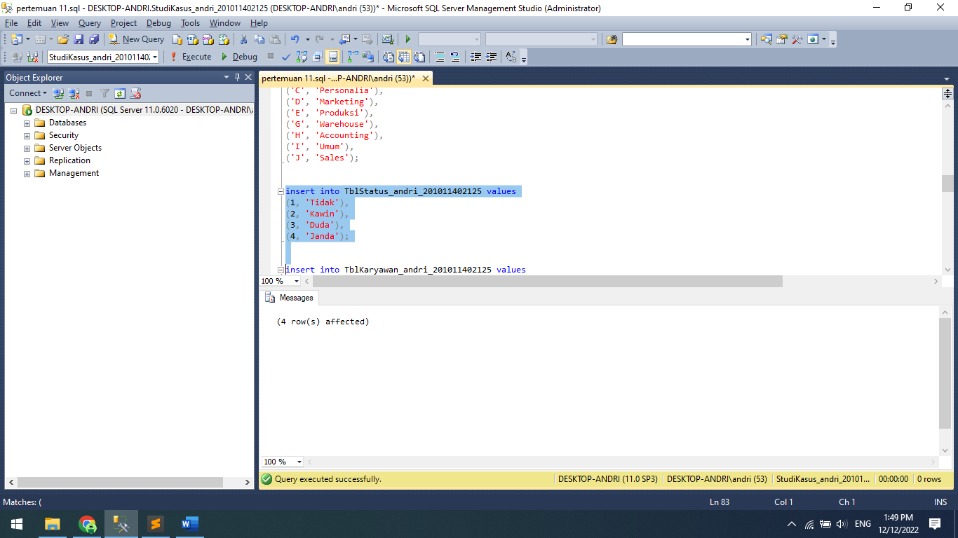

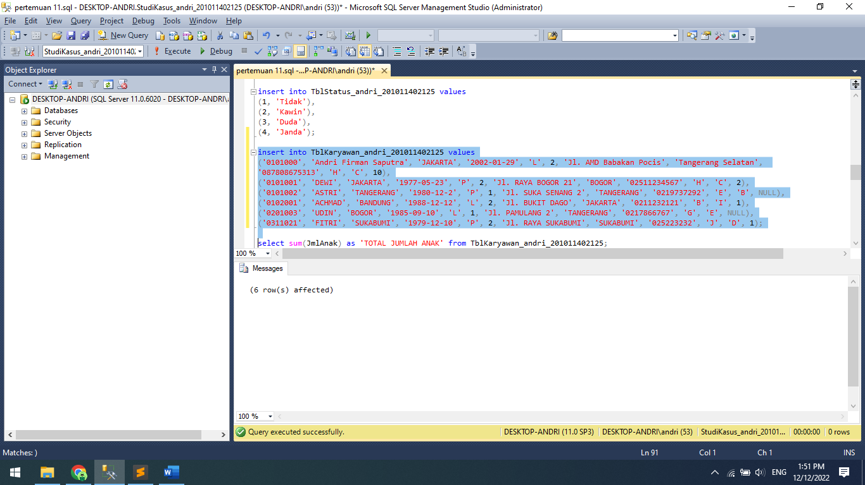

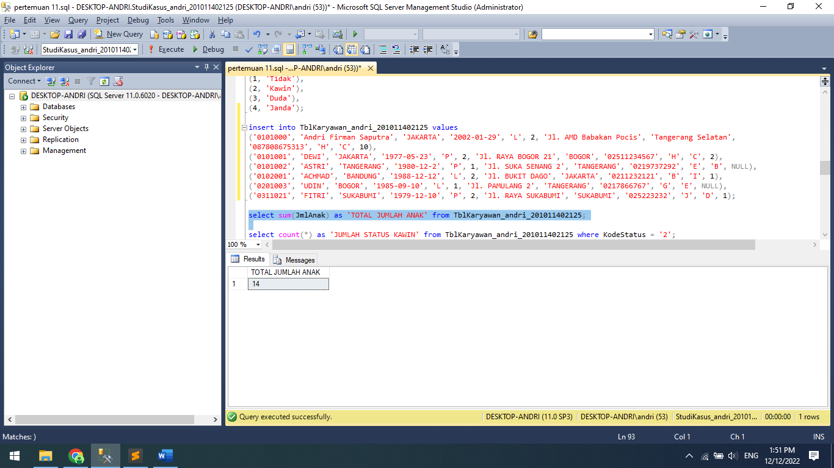

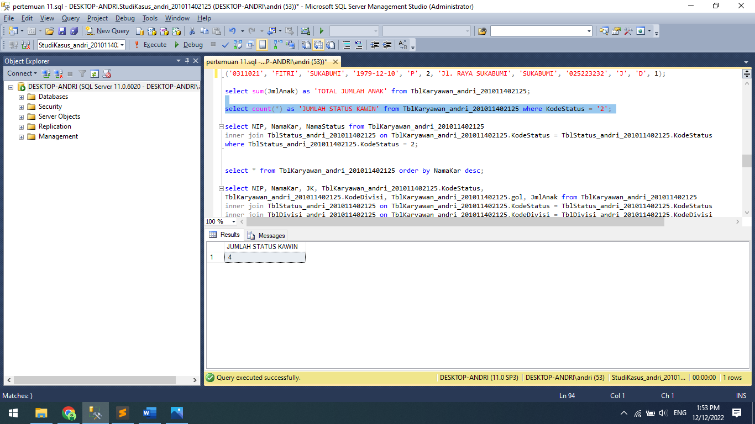

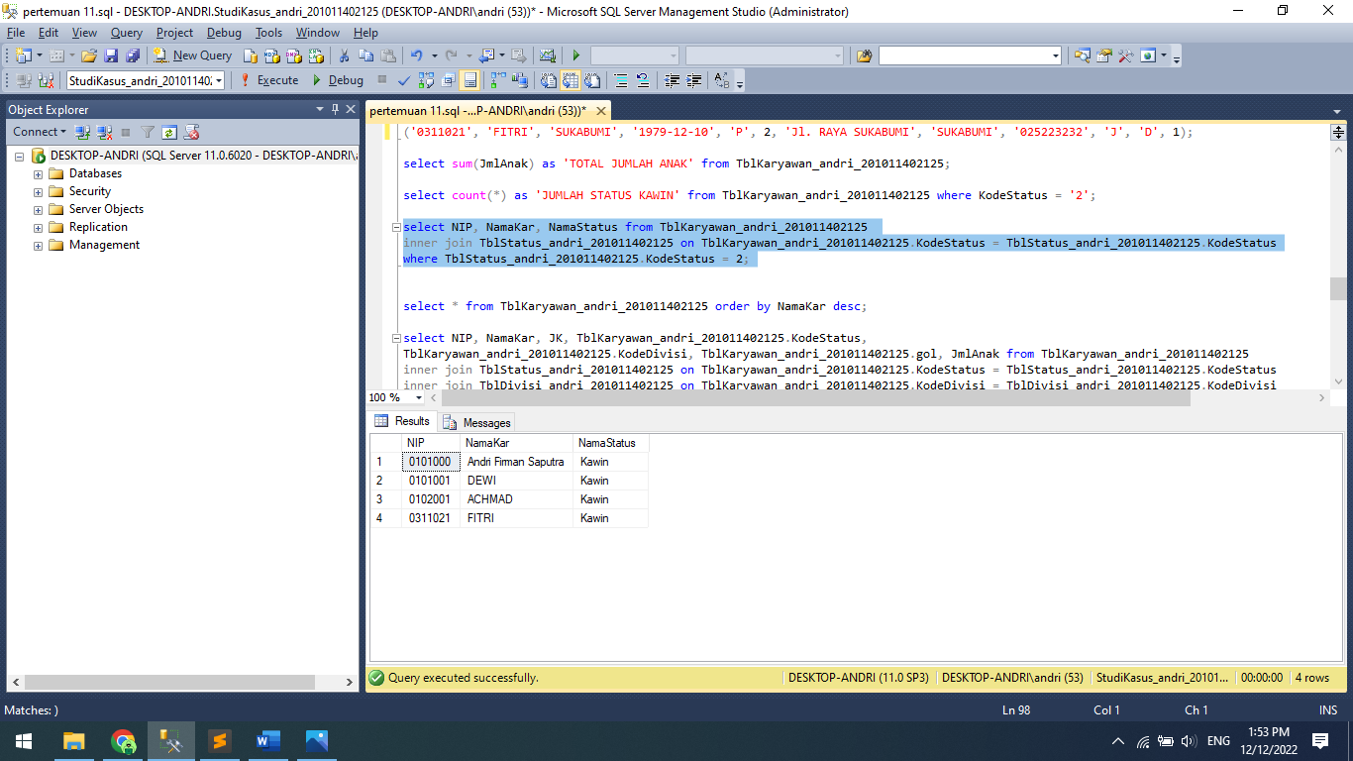

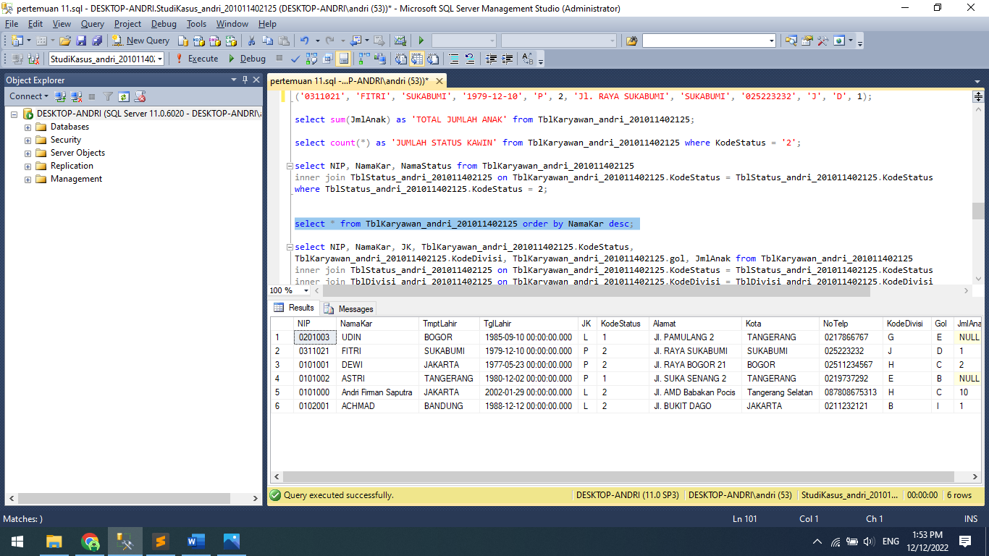

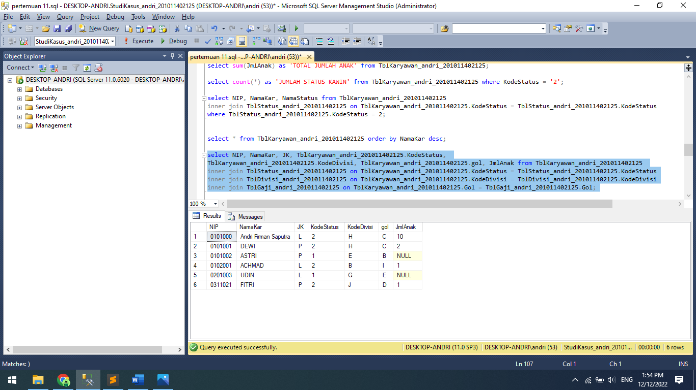

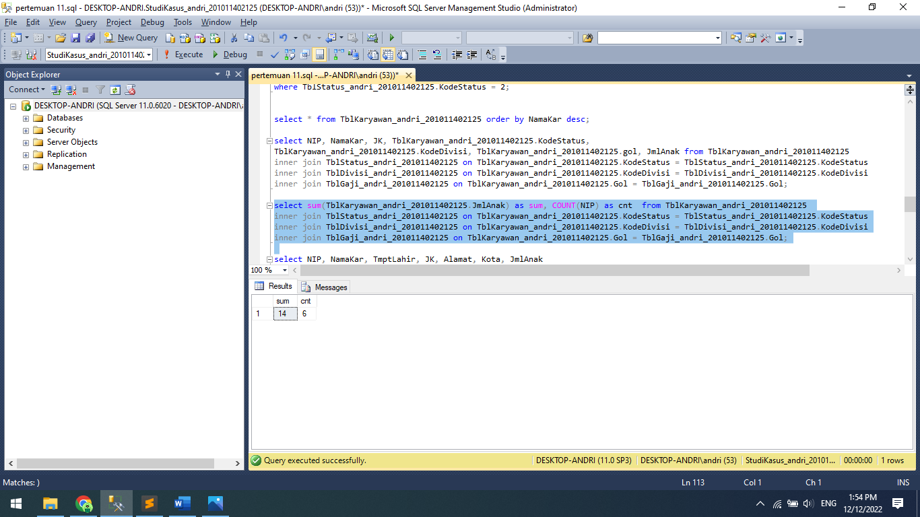

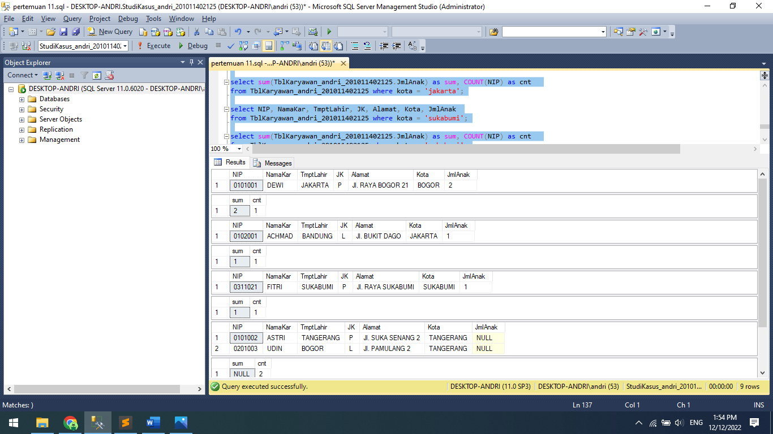

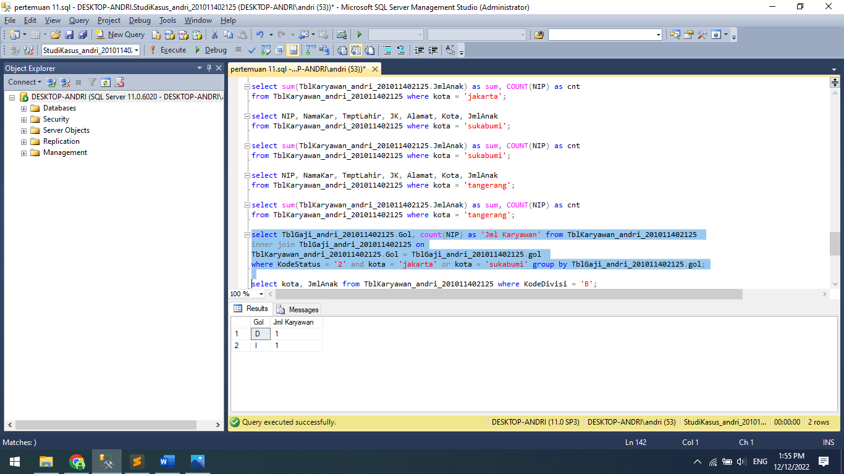

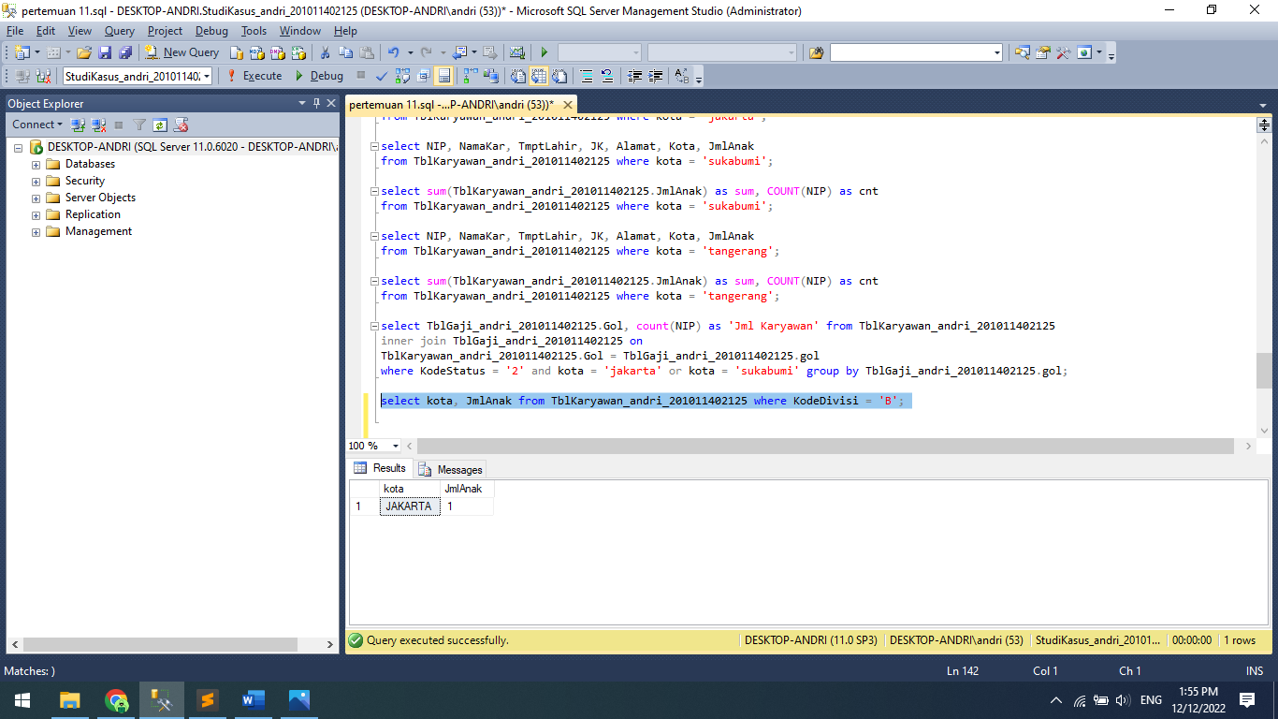

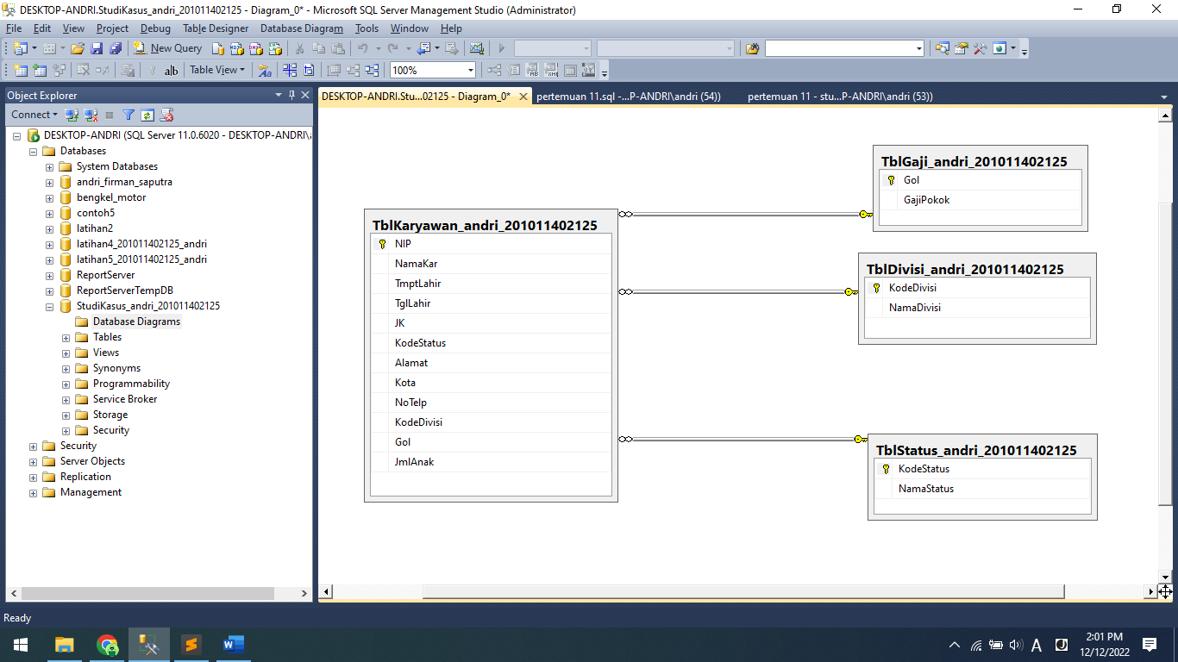

Source Code study kasus 1:

create database StudiKasus_andri_201011402125;

use StudiKasus_andri_201011402125;

create table TblKaryawan_andri_201011402125 (

NIP nchar(10) not null,

NamaKar nchar(50) not null,

TmptLahir nchar(50) not null,

TglLahir datetime not null,

JK nchar(1) not null,

KodeStatus int not null,

Alamat text not null,

Kota nchar(50) not null,

NoTelp nchar(20) not null,

KodeDivisi nchar(5) not null,

Gol nchar(5) not null,

JmlAnak int null,

primary key(NIP)

);

create table TblDivisi_andri_201011402125 (

KodeDivisi nchar(5) not null,

NamaDivisi nchar(50) not null,

primary key(KodeDivisi)

);

create table TblGaji_andri_201011402125 (

Gol nchar(5) not null,

GajiPokok money not null,

primary key(Gol)

);

create table TblStatus_andri_201011402125 (

KodeStatus int not null,

NamaStatus nchar(50) not null,

primary key (KodeStatus)

);

alter table TblKaryawan_andri_201011402125

add constraint FK_Divisi_andri_201011402125 foreign Key (KodeDivisi)

references TblDivisi_andri_201011402125(KodeDivisi);

alter table TblKaryawan_andri_201011402125

add constraint FK_Gaji_andri_201011402125 foreign Key (Gol)

references TblGaji_andri_201011402125(Gol);

alter table TblKaryawan_andri_201011402125

add constraint FK_Status_andri_201011402125 foreign Key (KodeStatus)

references TblStatus_andri_201011402125(KodeStatus);

insert into TblGaji_andri_201011402125 values

('A', 750000),

('B', 1000000),

('C', 1250000),

('D', 1500000),

('E', 1750000),

('F', 2000000),

('G', 2500000),

('H', 3000000),

('I', 4000000),

('J', 5000000);

insert into TblDivisi_andri_201011402125 values

('A', 'Direktur'),

('B', 'Manager'),

('C', 'Personalia'),

('D', 'Marketing'),

('E', 'Produksi'),

('G', 'Warehouse'),

('H', 'Accounting'),

('I', 'Umum'),

('J', 'Sales');

insert into TblStatus_andri_201011402125 values

(1, 'Tidak'),

(2, 'Kawin'),

(3, 'Duda'),

(4, 'Janda');

insert into TblKaryawan_andri_201011402125 values

('0101000', 'Andri Firman Saputra', 'JAKARTA', '2002-01-29', 'L', 2, 'Jl. AMD Babakan Pocis', 'Tangerang Selatan',

'087808675313', 'H', 'C', 10),

('0101001', 'DEWI', 'JAKARTA', '1977-05-23', 'P', 2, 'Jl. RAYA BOGOR 21', 'BOGOR', '02511234567', 'H', 'C', 2),

('0101002', 'ASTRI', 'TANGERANG', '1980-12-2', 'P', 1, 'Jl. SUKA SENANG 2', 'TANGERANG', '0219737292', 'E', 'B', NULL),

('0102001', 'ACHMAD', 'BANDUNG', '1988-12-12', 'L', 2, 'Jl. BUKIT DAGO', 'JAKARTA', '0211232121', 'B', 'I', 1),

('0201003', 'UDIN', 'BOGOR', '1985-09-10', 'L', 1, 'Jl. PAMULANG 2', 'TANGERANG', '0217866767', 'G', 'E', NULL),

('0311021', 'FITRI', 'SUKABUMI', '1979-12-10', 'P', 2, 'Jl. RAYA SUKABUMI', 'SUKABUMI', '025223232', 'J', 'D', 1);

select sum(JmlAnak) as 'TOTAL JUMLAH ANAK' from TblKaryawan_andri_201011402125;

select count(*) as 'JUMLAH STATUS KAWIN' from TblKaryawan_andri_201011402125 where KodeStatus = '2';

select NIP, NamaKar, NamaStatus from TblKaryawan_andri_201011402125

inner join TblStatus_andri_201011402125 on TblKaryawan_andri_201011402125.KodeStatus = TblStatus_andri_201011402125.KodeStatus

where TblStatus_andri_201011402125.KodeStatus = 2;

select * from TblKaryawan_andri_201011402125 order by NamaKar desc;

select NIP, NamaKar, JK, TblKaryawan_andri_201011402125.KodeStatus,

TblKaryawan_andri_201011402125.KodeDivisi, TblKaryawan_andri_201011402125.gol, JmlAnak from TblKaryawan_andri_201011402125

inner join TblStatus_andri_201011402125 on TblKaryawan_andri_201011402125.KodeStatus = TblStatus_andri_201011402125.KodeStatus

inner join TblDivisi_andri_201011402125 on TblKaryawan_andri_201011402125.KodeDivisi = TblDivisi_andri_201011402125.KodeDivisi

inner join TblGaji_andri_201011402125 on TblKaryawan_andri_201011402125.Gol = TblGaji_andri_201011402125.Gol;

select sum(TblKaryawan_andri_201011402125.JmlAnak) as sum, COUNT(NIP) as cnt from TblKaryawan_andri_201011402125

inner join TblStatus_andri_201011402125 on TblKaryawan_andri_201011402125.KodeStatus = TblStatus_andri_201011402125.KodeStatus

inner join TblDivisi_andri_201011402125 on TblKaryawan_andri_201011402125.KodeDivisi = TblDivisi_andri_201011402125.KodeDivisi

inner join TblGaji_andri_201011402125 on TblKaryawan_andri_201011402125.Gol = TblGaji_andri_201011402125.Gol;

select NIP, NamaKar, TmptLahir, JK, Alamat, Kota, JmlAnak

from TblKaryawan_andri_201011402125 where kota = 'bogor';

select sum(TblKaryawan_andri_201011402125.JmlAnak) as sum, COUNT(NIP) as cnt

from TblKaryawan_andri_201011402125 where kota = 'bogor';

select NIP, NamaKar, TmptLahir, JK, Alamat, Kota, JmlAnak

from TblKaryawan_andri_201011402125 where kota = 'jakarta';

select sum(TblKaryawan_andri_201011402125.JmlAnak) as sum, COUNT(NIP) as cnt

from TblKaryawan_andri_201011402125 where kota = 'jakarta';

select NIP, NamaKar, TmptLahir, JK, Alamat, Kota, JmlAnak

from TblKaryawan_andri_201011402125 where kota = 'sukabumi';

select sum(TblKaryawan_andri_201011402125.JmlAnak) as sum, COUNT(NIP) as cnt

from TblKaryawan_andri_201011402125 where kota = 'sukabumi';

select NIP, NamaKar, TmptLahir, JK, Alamat, Kota, JmlAnak

from TblKaryawan_andri_201011402125 where kota = 'tangerang';

select sum(TblKaryawan_andri_201011402125.JmlAnak) as sum, COUNT(NIP) as cnt

from TblKaryawan_andri_201011402125 where kota = 'tangerang';

select TblGaji_andri_201011402125.Gol, count(NIP) as 'Jml Karyawan' from TblKaryawan_andri_201011402125

inner join TblGaji_andri_201011402125 on

TblKaryawan_andri_201011402125.Gol = TblGaji_andri_201011402125.gol

where KodeStatus = '2' and kota = 'jakarta' or kota = 'sukabumi' group by TblGaji_andri_201011402125.gol;

select kota, JmlAnak from TblKaryawan_andri_201011402125 where KodeDivisi = 'B';

Study Kasus 2

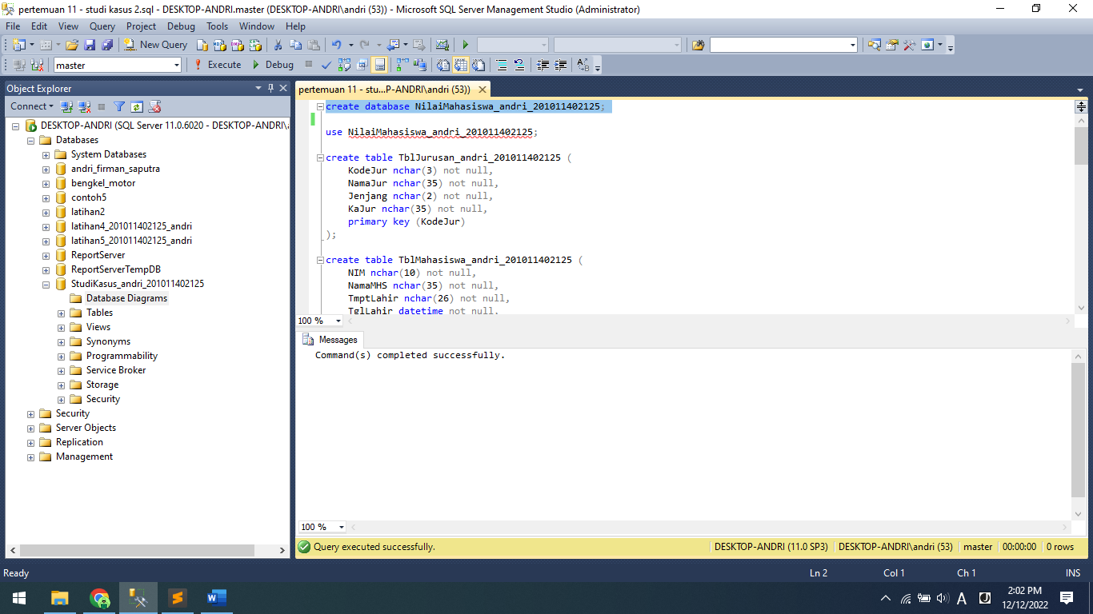

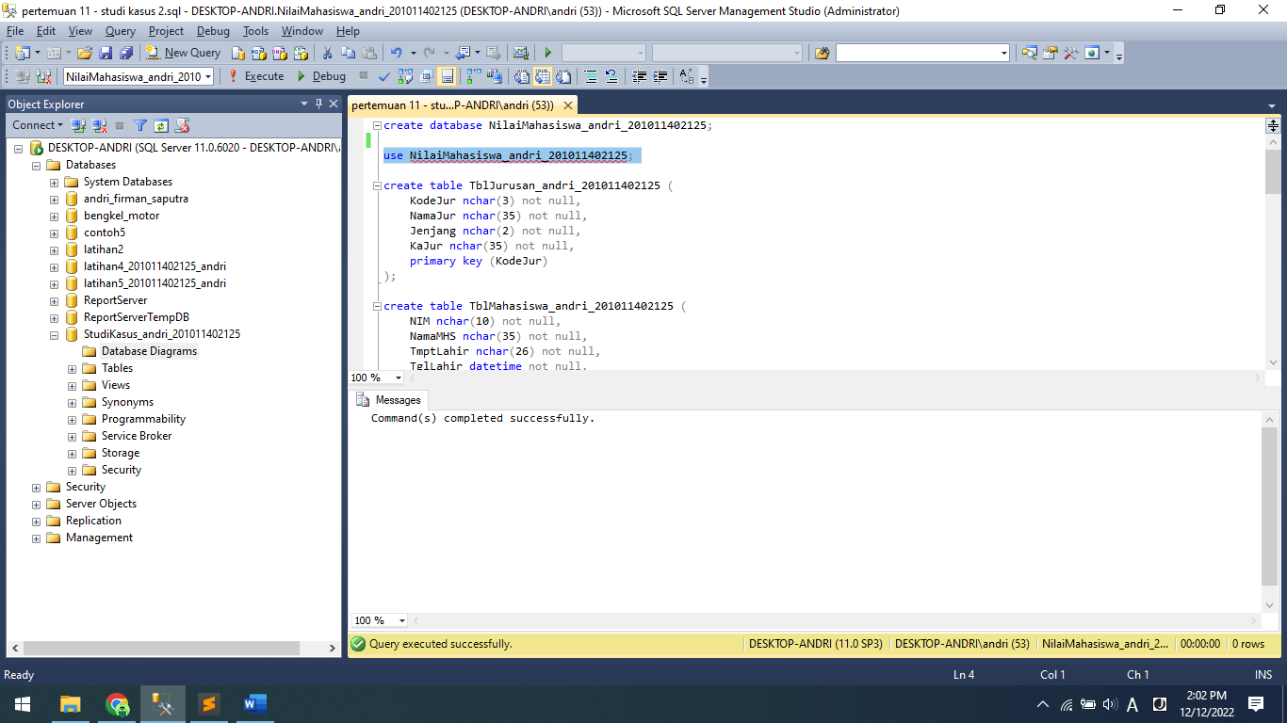

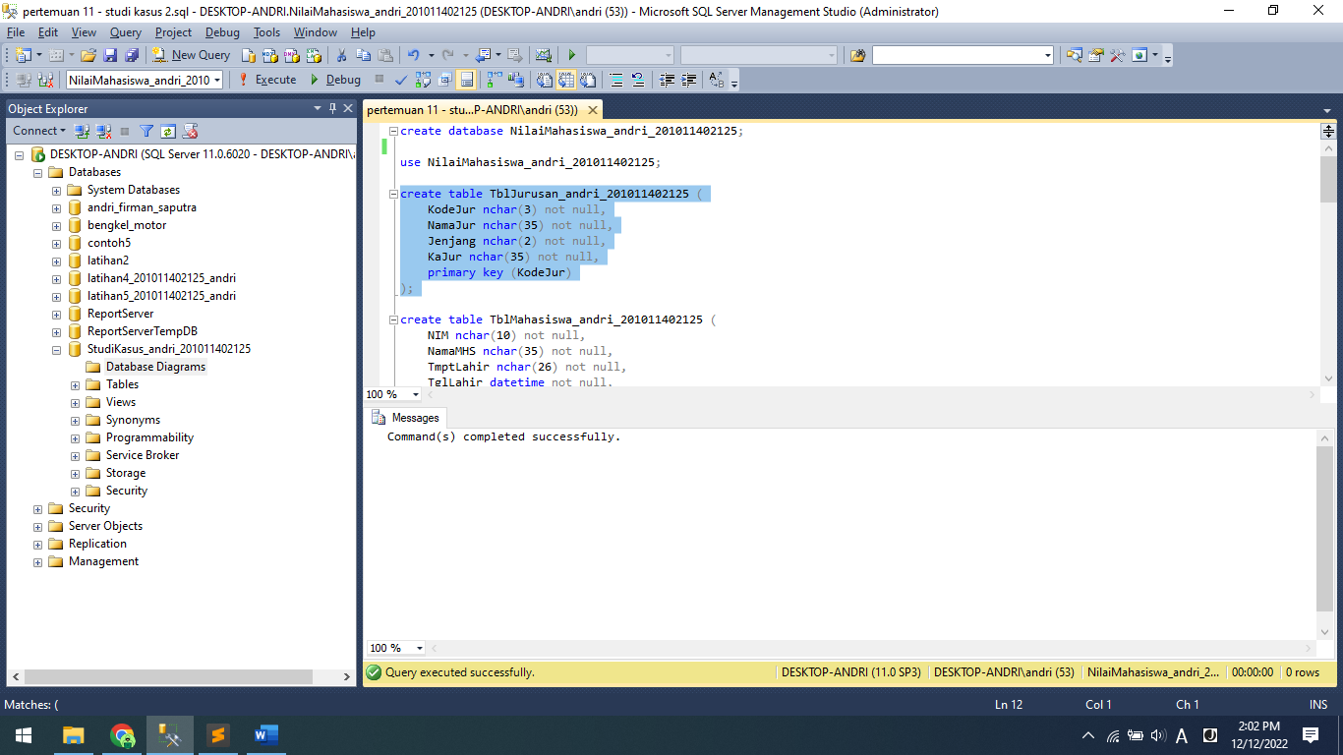

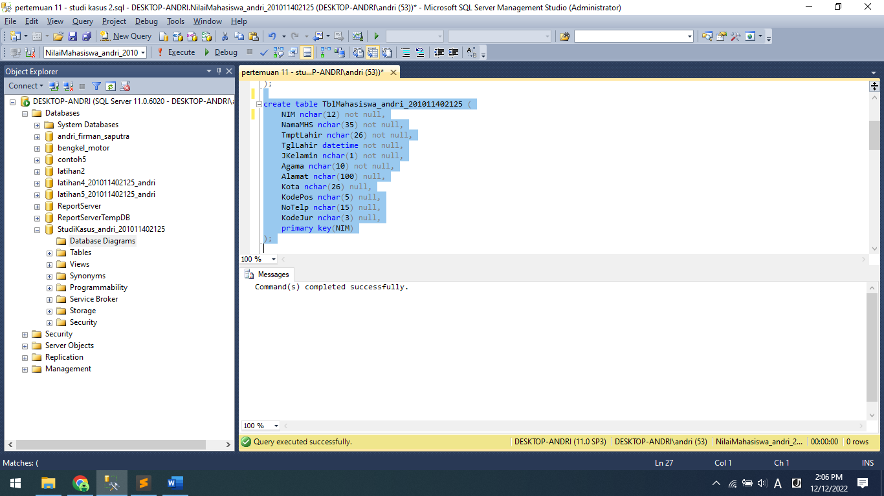

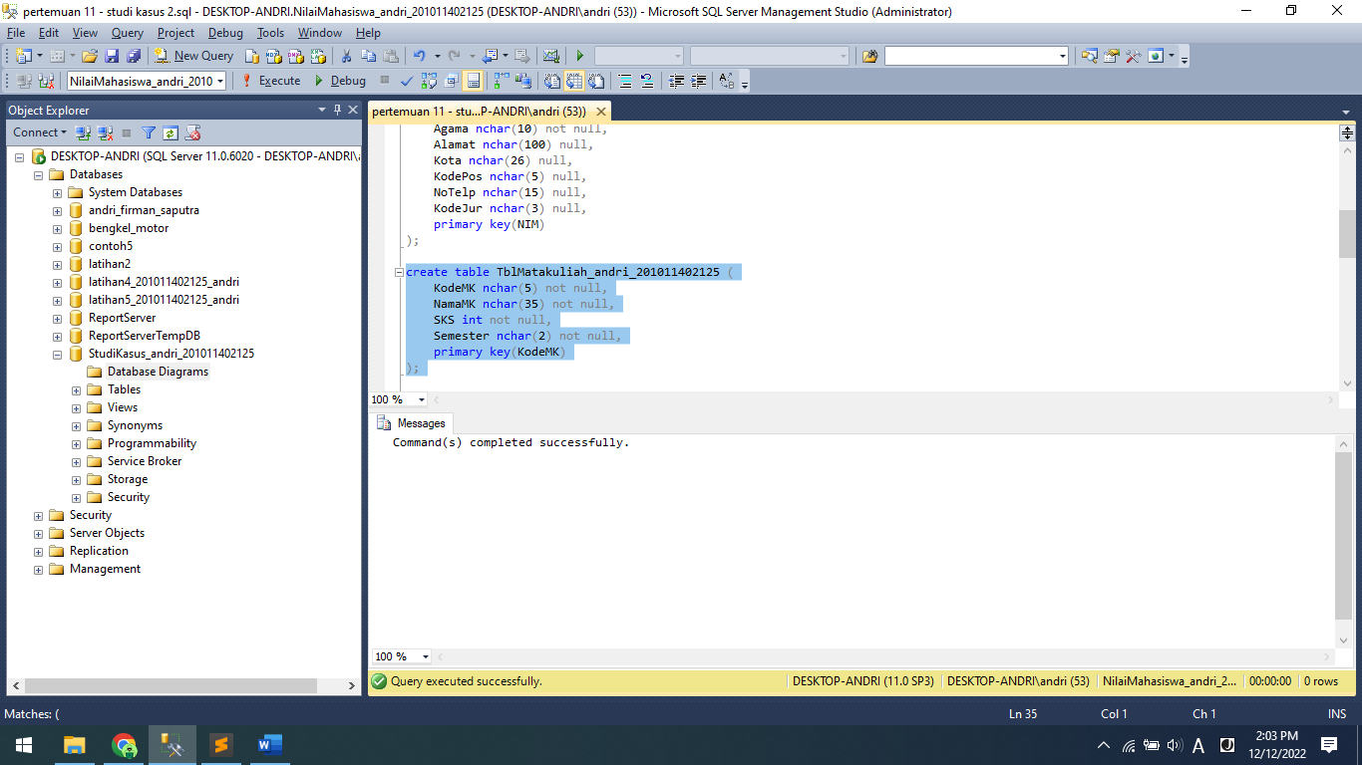

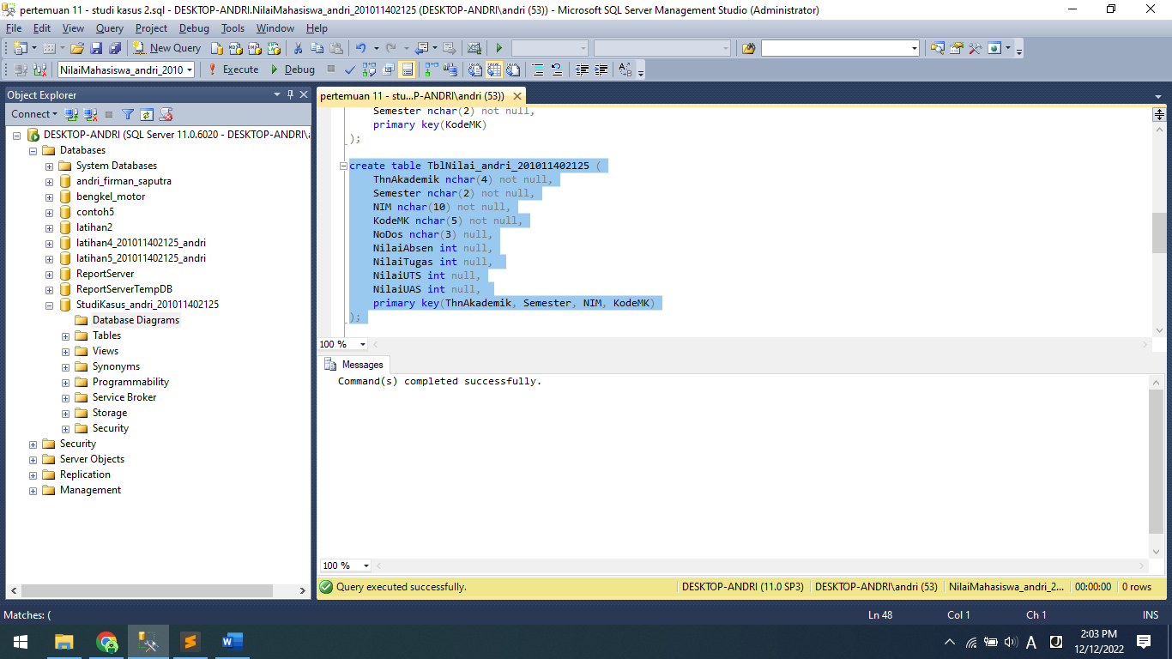

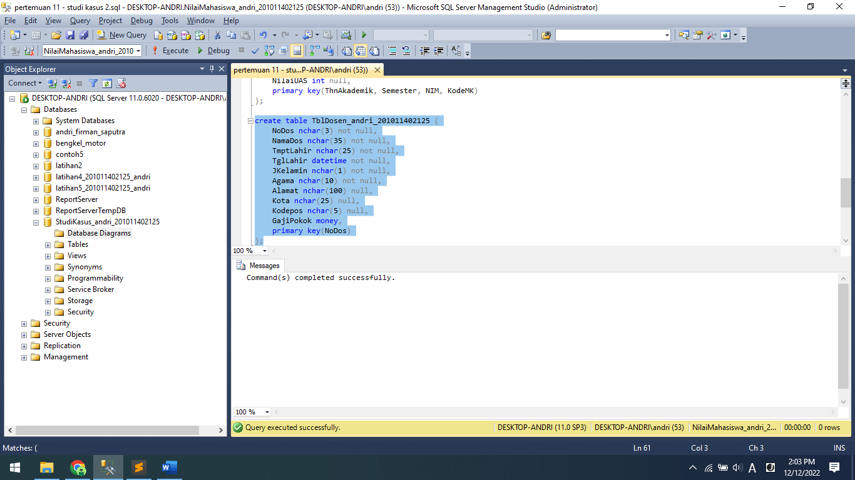

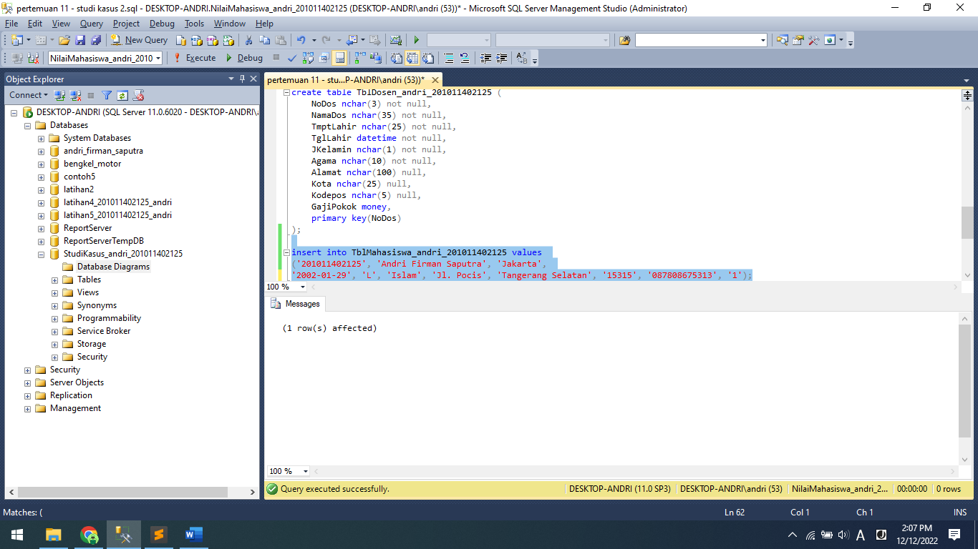

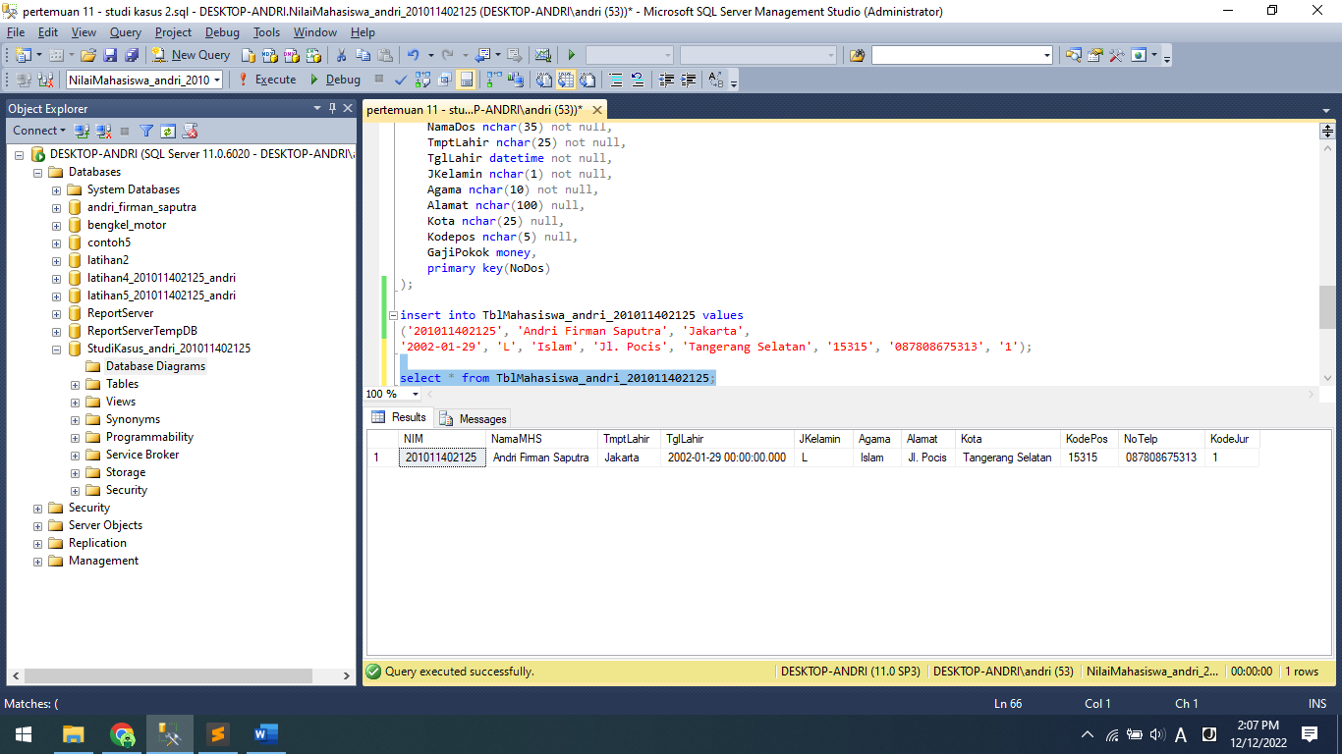

Source Code:

create database NilaiMahasiswa_andri_201011402125;

use NilaiMahasiswa_andri_201011402125;

create table TblJurusan_andri_201011402125 (

KodeJur nchar(3) not null,

NamaJur nchar(35) not null,

Jenjang nchar(2) not null,

KaJur nchar(35) not null,

primary key (KodeJur)

);

create table TblMahasiswa_andri_201011402125 (

NIM nchar(12) not null,

NamaMHS nchar(35) not null,

TmptLahir nchar(26) not null,

TglLahir datetime not null,

JKelamin nchar(1) not null,

Agama nchar(10) not null,

Alamat nchar(100) null,

Kota nchar(26) null,

KodePos nchar(5) null,

NoTelp nchar(15) null,

KodeJur nchar(3) null,

primary key(NIM)

);

create table TblMatakuliah_andri_201011402125 (

KodeMK nchar(5) not null,

NamaMK nchar(35) not null,

SKS int not null,

Semester nchar(2) not null,

primary key(KodeMK)

);

create table TblNilai_andri_201011402125 (

ThnAkademik nchar(4) not null,

Semester nchar(2) not null,

NIM nchar(10) not null,

KodeMK nchar(5) not null,

NoDos nchar(3) null,

NilaiAbsen int null,

NilaiTugas int null,

NilaiUTS int null,

NilaiUAS int null,

primary key(ThnAkademik, Semester, NIM, KodeMK)

);

create table TblDosen_andri_201011402125 (

NoDos nchar(3) not null,

NamaDos nchar(35) not null,

TmptLahir nchar(25) not null,

TglLahir datetime not null,

JKelamin nchar(1) not null,

Agama nchar(10) not null,

Alamat nchar(100) null,

Kota nchar(25) null,

Kodepos nchar(5) null,

GajiPokok money,

primary key(NoDos)

);

insert into TblMahasiswa_andri_201011402125 values

('201011402125', 'Andri Firman Saputra', 'Jakarta',

'2002-01-29', 'L', 'Islam', 'Jl. Pocis', 'Tangerang Selatan', '15315', '087808675313', '1');

select * from TblMahasiswa_andri_201011402125;